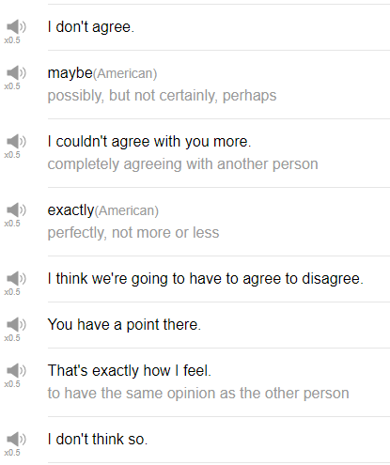

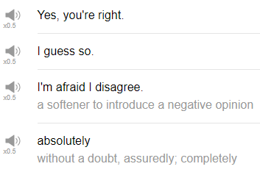

|  |
| --- |
| Vamos a la piscina, that means "we're going to the movie theater", right? |
| Alright! Hi everybody, my name is Alisha. Welcome back to Top Words. Today we're going to be talking about must know expressions for agreeing and disagreeing, very useful, so let's go! |
| 1. Exactly. |
| When you agree 100% with something someone else has said, you can say exactly. For example, ramen is one of the best food in the world. Exactly. |
| 2. I don't agree. |
| You have a different opinion from the other person, they tell you, I think that soccer is the best sport, you can say, I don't agree. But be prepared to provide your own opinion after this. I think soccer is the best sport I don't agree, I think that football is. Oh! that could cause some problems! Soccer/football. Americans say football when we mean American football, but the rest of the world says football when they mean soccer. |
| 3. Maybe. |
| Maybe is when you don't know, when you can't make a decision, or when you're not sure about something. Okay so someone tosses you an opinion, someone says they're their idea to you, I think it's gonna rain tomorrow, you can say, yeah maybe. You don't know for sure, yes or no, but it's possible, it's a good sort of in-between expression, but if you use maybe all the time, it's going to sound really strange, and it's going to sound like you can't make a decision. So use maybe very sparingly, don't use it so often. Maybe is very commonly used as a soft no, it's up to you to figure that out among the people that you're talking to then. You want to stay over my house this weekend? Maybe. |
| 4. I couldn't agree with you more. |
| You are in complete agreement with the other person, and really want to communicate that to them. You think that what they have just said is really really correct, super correct, yes! You are completely on board with that idea, you can say "I couldn't agree with you more". I couldn't, the negative form, I could not agree with you more, meaning it's not possible that I could agree more with what you're saying. Next week it's really important that we have a barbecue because summer is ending. And then your friend can say, I couldn't agree more! That's a fantastic big idea, I'll buy steak. |
| 5. I think we're going to have to agree to disagree. |
| Agree to disagree, this is a kind of, it seems like a simple phrase, agree to disagree. So you're agreeing with the other person, you agree that we have a different opinion, agree to disagree. I would use this expression at the end of a discussion, so person A and person B have different opinions and they've been discussing those opinions for a long time, and person A is not changing his or her opinion, person B is not changing his or her opinion, so you can say at the end of the conversation, okay we have to agree to disagree. Let's just accept our different opinions and move on in the conversation. |
| 6. You have a point there. |
| This is not necessarily and an agreement or disagreement phrase, it's a small agreement within a larger discussion, so maybe you've been discussing a topic for a long time, and you disagreed with the other person until this time. This person says something and you agree with that, ah, you have a point there. So there's one thing that this person has said that you can agree with, you can say you have a point there. I think that's correct, or I agree with that point. |
| 7. That's exactly how I feel. |
| Meaning, my feeling is the same as you're feeling, or my opinion is the same as your opinion, that's exactly how I feel. Maybe you can use this if someone describes your feeling very accurately, for example, you can say, I feel like the company is really heading in a nice new direction, you can say, yeah, that's exactly how I feel, I really like the new boss. |
| 8. I don't think so. |
| It's soft, it's not so direct, it's not a hard "I disagree", but just I don't think so. Of course you can use it to discuss opinions but you can also use it when you're making plans. Are you going to that party this weekend? I don't think so. It's not a disagreement but it can be used as a negation phrase, and a negative response to something. When used as an opinion, I think Chinese is the hardest language to learn, you can say, I don't think so, I think that Arabic is the hardest language to learn. |
| 9. Yes, you're right. |
| Yes, you're right means you're correct, yes, I agree with you, I think that's the right information, I think that's the correct opinion. Just a very clear agreement phrase, you're right. It also has the nuance of being correct, so maybe there was a possibility the other person could be incorrect. Did you know that pepperoni pizza is the most delicious pizza in the world? Yes, you're right. You can change it to “that's right” for that opinion. You can use you're to talk specifically about the person itself, but that's right, yes, that's right, that information is correct. |
| 10. I guess so. |
| I guess so, it's an agreement but it's sort of a flaky agreement, I guess so. It's like you don't really want to make a decision but you don't feel strongly in one, like, in agreement or disagreement, you can say I guess so. It's usually said with this tone of voice, I guess so. You know, we don't say I guess so! Generally it's like you can't quite make a decision or you don't want to make a decision, you can say I guess so. Hey, we're gonna go for Chinese food for dinner tonight, you wanna come? Yeah I guess so. You don't feel strongly either way. I guess so. |
| 11. I'm afraid I disagree. |
| It's a rather polite expression that you can use in a business situation, for example. I'm afraid here doesn't mean I'm actually scared or I'm really frightened, but just it's a softener that's used at the beginning of sentences to introduce a negative opinion. So I'm afraid I disagree, or I'm afraid I can't agree with you, for example. I think that you need to adopt a new policy for your company. I'm afraid I disagree. It's a soft disagreement that sounds a bit more formal than some of the other phrases we've talked about so far. |
| 12. Absolutely. |
| Absolutely means 100% yes, exactly, precisely, definitely, it's a quick and clear and can be polite as well as casual word that means you agree with the other person. Hey, do you want to go to the beach this weekend? Yeah, absolutely! Absolutely! |
| Oh, that's the end! So those are some phrases that you can use to agree and disagree with other people. There are a lot of them, and you can kind of mix and match them as you see fit. So give them a try. Thanks very much for watching this episode of Top Words and we'll see you again soon. Bye! |